ERASMUS+ Partner Countries KA107: STAFF incoming mobility for teaching (STA)
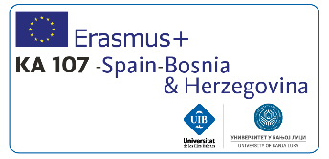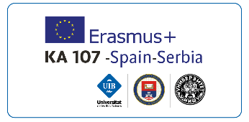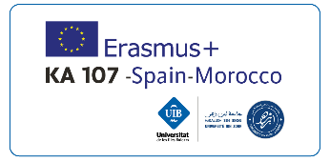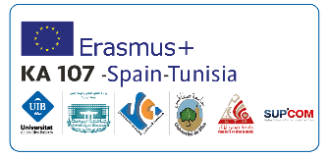
In coordinating the ERASMUS+ Partner Countries KA107 programme, the University of the Balearic Islands announces 8 grants to support staff mobility for teaching (STA) from universities in Serbia, Bosnia and Herzegovina, Morocco, and Tunisia to come to the UIB during the 2017-2018 and 2018-2019 academic years, under the framework of the ERASMUS+ Partner Countries KA107 programme.
The 8 grants are designed to cover part of the travel and living costs of the professors from universities in Serbia, Bosnia and Herzegovina, Morocco, and Tunisia, countries with which there is an inter-institutional ERASMUS+ agreement signed for teaching at the UIB.
Teaching stays must take place during the period from 1 March 2018 to 30 June 2019.
To apply for a mobility within ERASMUS+ Partner Countries KA107 you have to fill in an on line application form and send the required documents by email.

Requirements for requesting a place
To apply to a mobility within ERASMUS+ Partner countries KA107 you have to fulfil the following requirements:
- Applicants must have a contractual relationship at one of the partner universities (Serbia, Bosnia and Herzegovina, Morocco, or Tunisia) at the time of applying and while abroad.
- They must also present a mobility agreement for teaching staff approved by the home and host institutions in which the obligation to provide at least 8 hours of teaching during the 5-day stay is specified.

Duration of the teaching period
- The length of the teaching period is 5 days, and these 5 days should be consecutive. Teaching activities must be carried out for a minimum of 8 hours during the week.
- Weekends and days when no classes are held at the destination will be excluded from the computations indicated in the previous paragraph.
- Days when teaching will be carried out must be specified in the final mobility agreement and on the certificate of stay.
- Teaching stays must take place during the period from 1 March 2018 to 30 June 2019.

Financial assistance
The European Commission has established a European grant in order to contribute to the travel and living costs during the length of professors’ stays, in accordance with the following criteria:
A) Travel grant – Contribution to the travel costs based on the distance between the UIB and the origin university. Grant amount: €275 per participant. Distance calculator.
B) Individual grant – €120 per day of the stay (5 days of work + a maximum of 2 travel days).

Procedure for requesting a place
1st. Applicants must fill out the online application for ERASMUS+ Partner Countries Teaching Staff-2017.
2nd. Once the application is filled out, the following documentation* must be sent to erasmuska107@uib.es:
- A photocopy of the applicant’s passport.
- An official certificate accrediting a B2 (or equivalent) level of English or Spanish. The knowledge of other languages will be assessed by providing official certification.
- A proposal for the mobility agreement that will be carried out at the university being applied to. All sections must be filled out in detail and the temporary basis of the activities to be carried out must be specifically mentioned. This proposal must be duly signed by both the home and host universities upon submitting the application.
* This documentation must be sent by email within the time frame established in the call.

Call for academic courses 2017-18 and 2018-19

Call 2018-19
Call deadlines | Application submission | Decision / Accept / Renounce
February 26 to March 25, 2018 | May 09, 2018 | May 10 to May 14, 2018
- Terms of the call
- List of available places: Annex I of the call
- On-line application - opened from 26th February until 25th March 2018

